|  |  |
| --- | --- |
| Date | 05 November 2022 |
| Team ID | PNT2022TMID00940 |
| Project Name | SMART SOLUTIONS FOR RAILWAYS |

# SPRINT-2

**CREATING NODE-RED IN IBM CLOUD**

**STEP 1:** Open ibm cloud:

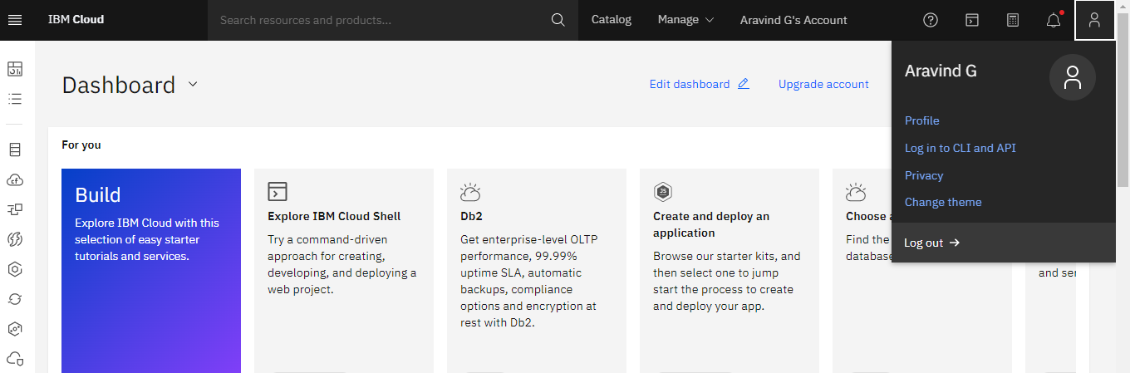

**STEP 2:** Go to catalog and search for node red app and open it:

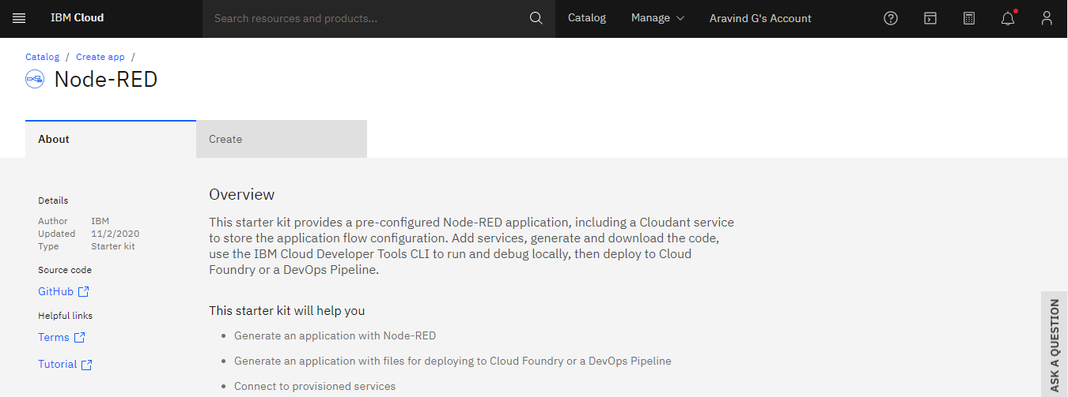

**STEP 3:** Enter the app name, location and select the plan and click on create.:

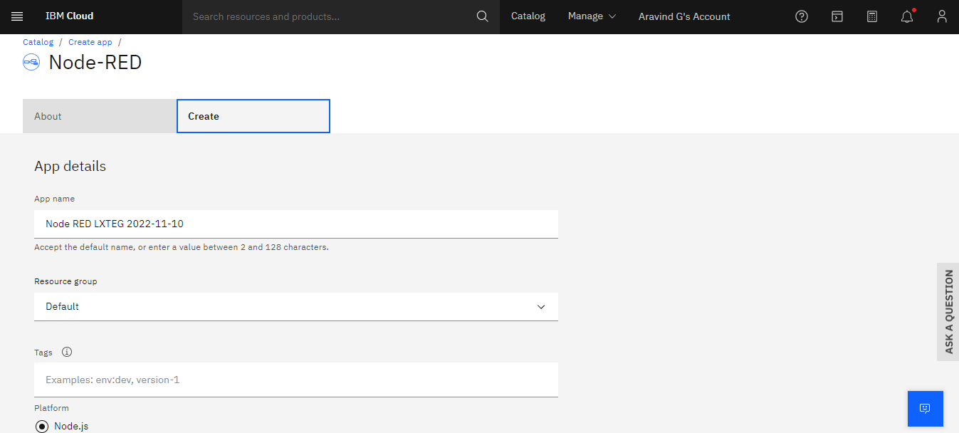

**STEP 4:** click on deploy your app button:

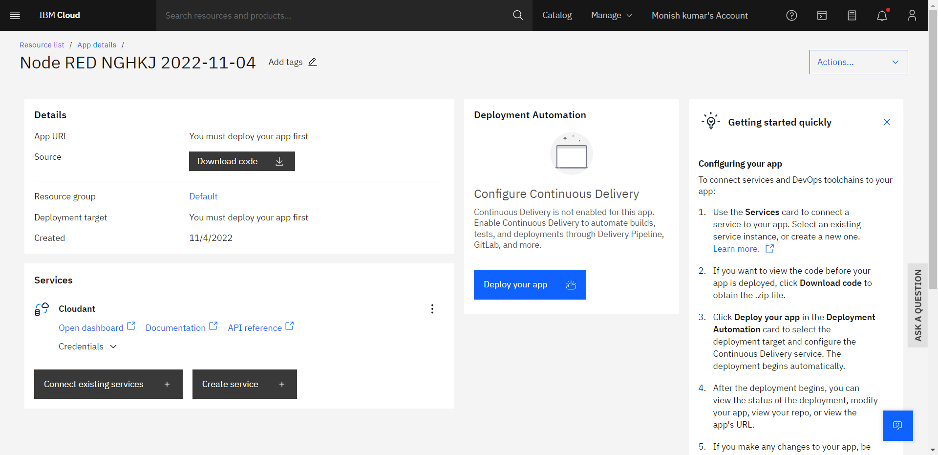

**STEP 5:** In deployment automation select cloud foundry and click on create.org:

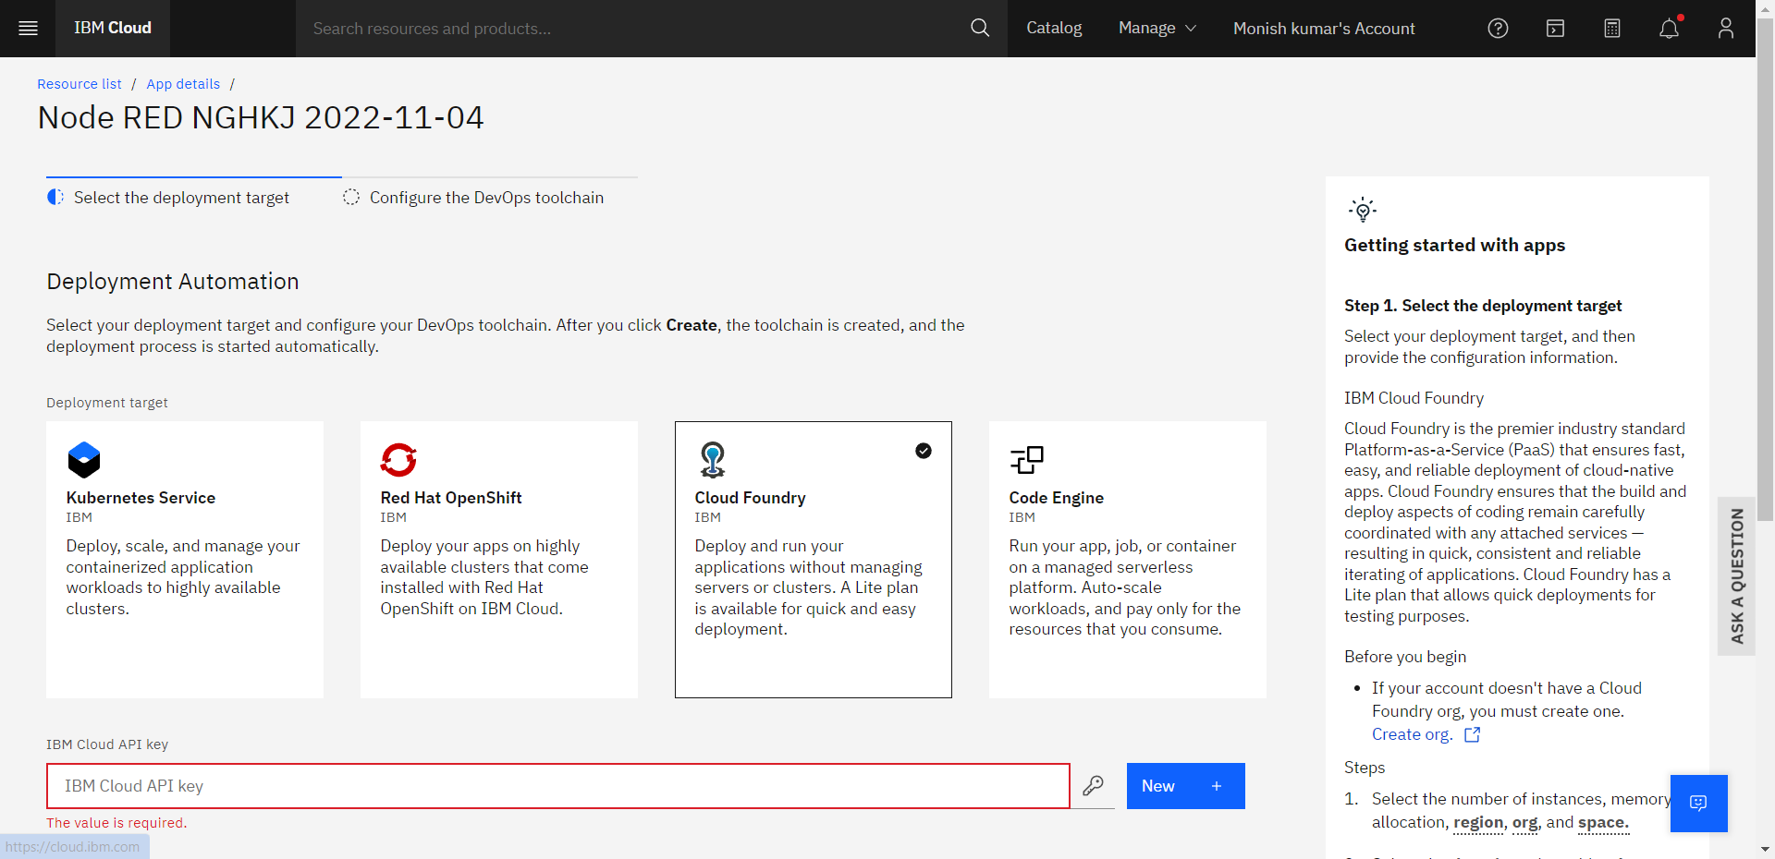

**STEP 6:** click on create button and enter the name and create a space:

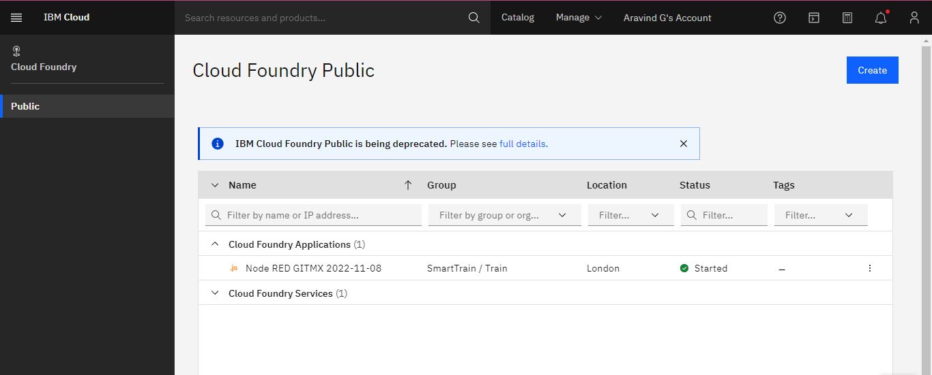

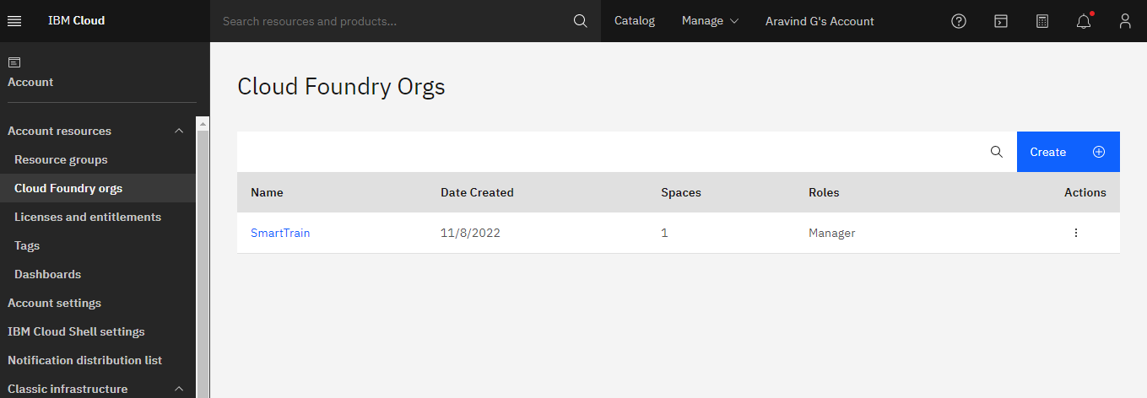

**STEP 7:** In app development click new on api key and select region and click next:

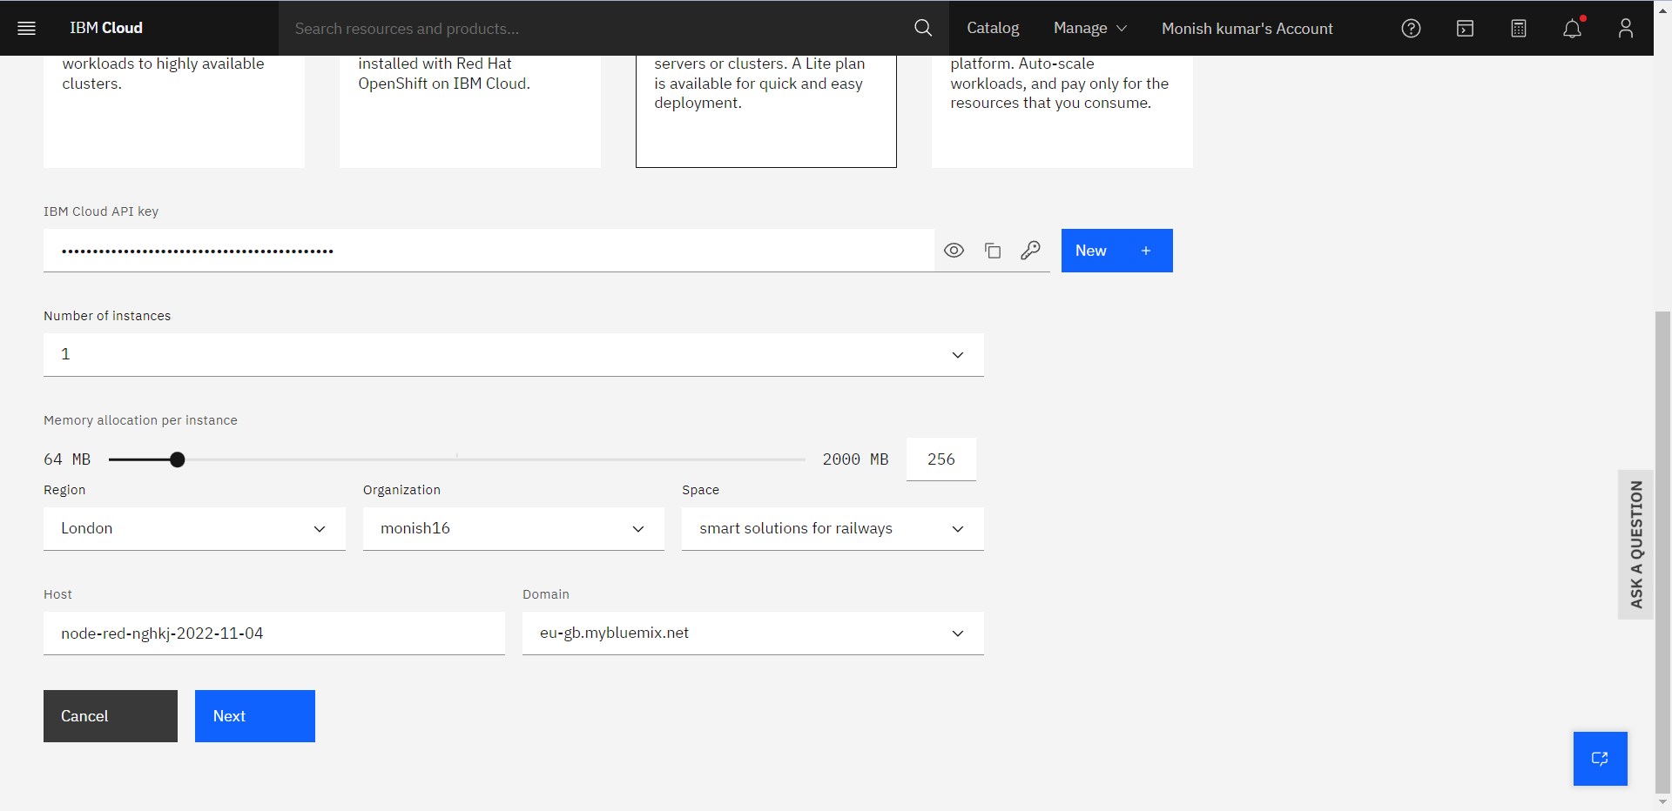

**STEP 8:** select the region and click create:

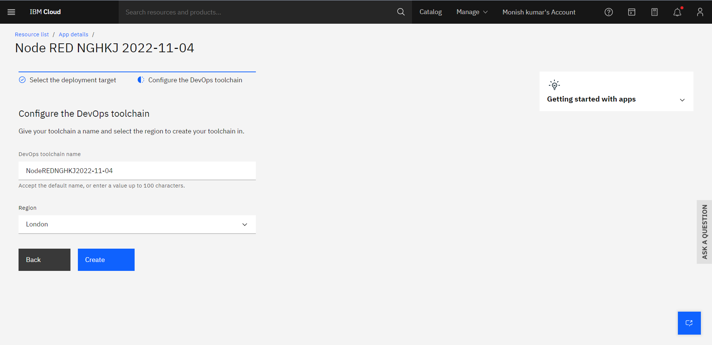

**STEP 9:** Wait till you get the success in ci-pipeline and app URL is generated:

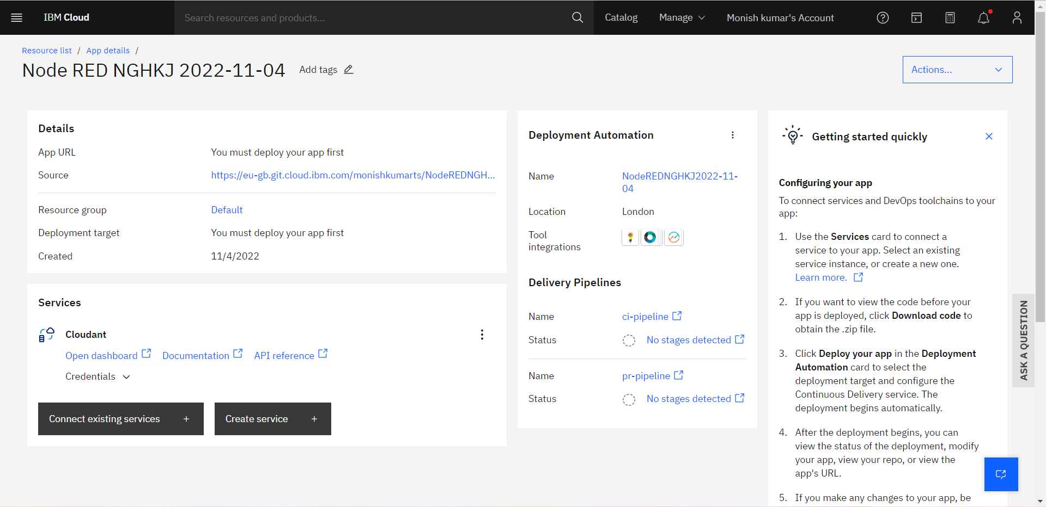

**STEP 10:** Now click on the generated APP URL:

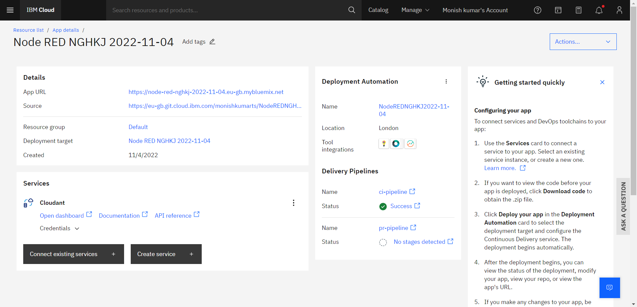

**STEP 11 :** You will redirected to your node-red on ibm cloud page:

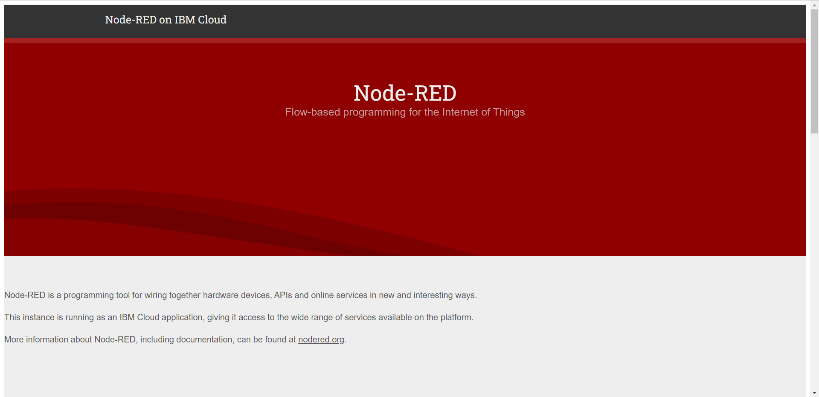

**STEP 12:** Click on node-red flow editor and you will be redirected to your node-red workspace:

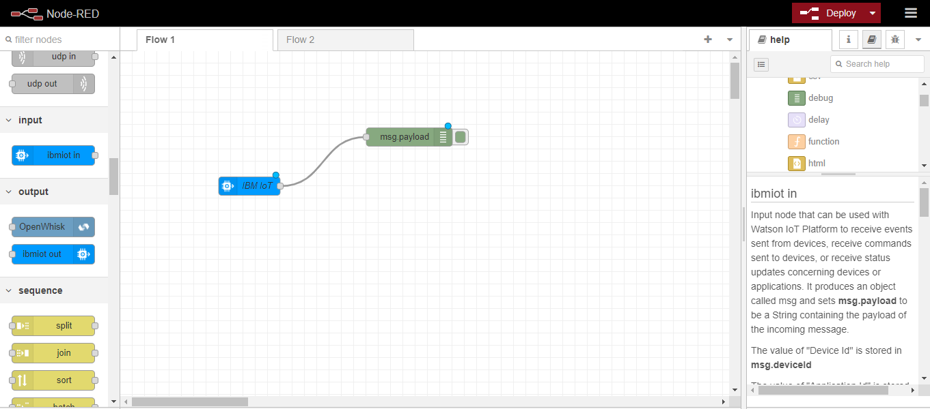

**STEP 13:** Generating API key and Authentication token:

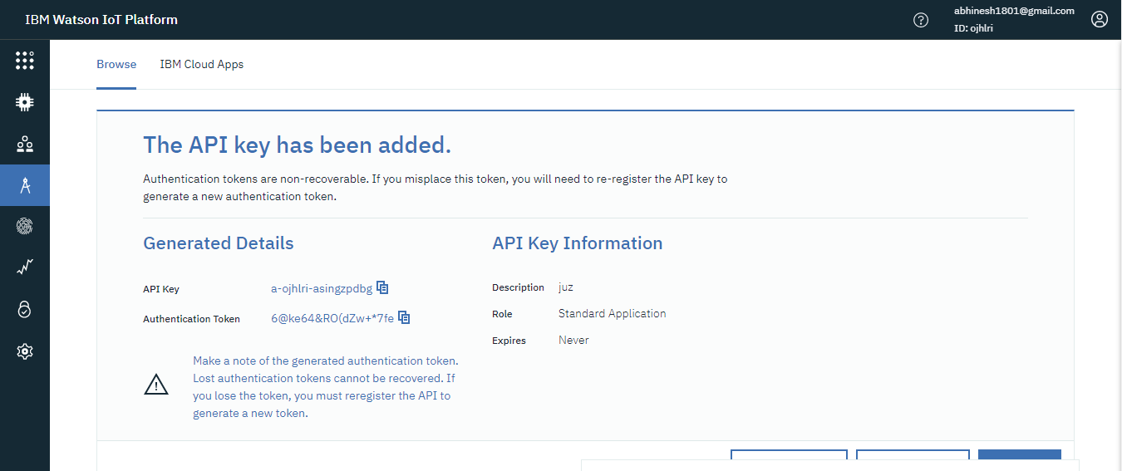

**STEP 14:** Edit Ibmiot in node:

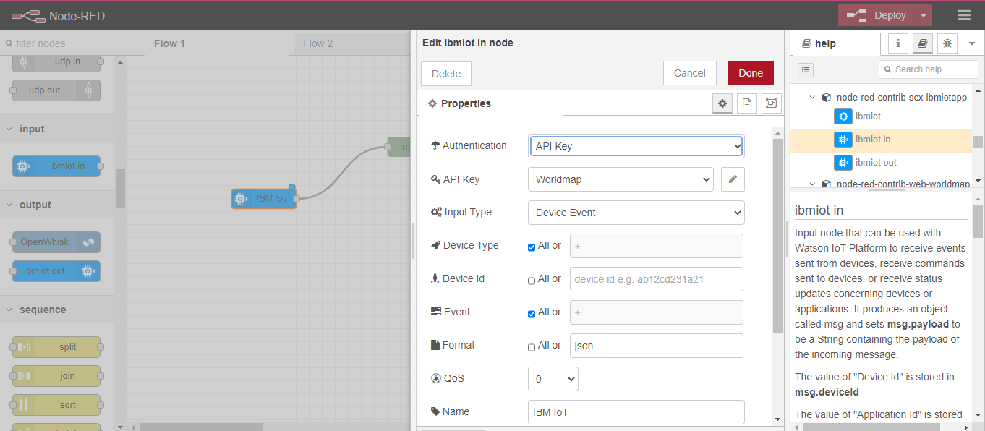

**STEP 15:** Connect Ibmiot in and debug 1 and deploy:

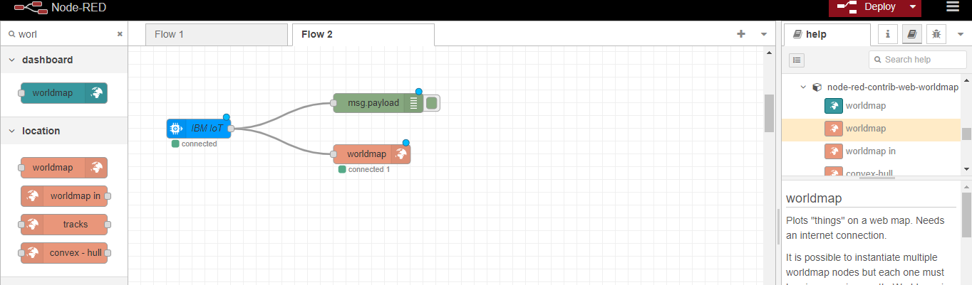

**STEP 16:** Generate debug message from IBM Watson IoT Platform and connect the nodes:

